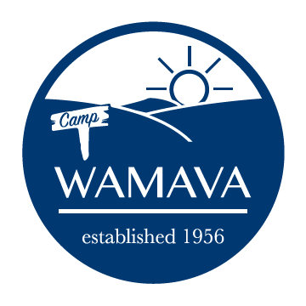
2023 Counselor Application

The primary responsibilities of counselors will be to supervise and lead campers. Camp WaMaVa seeks to employ a Spirit-led, professional staff in order to meet our mission of strengthening the campers' relationship with God, appreciating them, building friendships, and playing...lots of playing.

We desire honest and genuine responses to the questions below…not “right answers”. Please be thorough in your responses.

Interest
What is your name?

Why would you like to be a counselor? What do you hope to learn/gain from a summer at WaMaVa? If you are a previous WaMaVa counselor, also explain what you'd do differently.

What aspects of the counselor job description (found on website) make you uncomfortable? If you are a previous WaMaVa counselor, which aspects did you struggle with during your last employment at WaMaVa?

Youth Work Experience
Comprehensibly describe any training, work, or volunteer experience you’ve had dealing with young people. If you are a previous WaMaVa counselor, describe any experiences since your previous summer.

Spiritual Development
How have you stayed connected to a faith community this past year? What formal or informal ministries have you been involved in?

Are you a baptized Christian?

What are your spiritual gifts and personal strengths? How do you use them for others in your everyday life?

Describe a time that you spiritually led a group of people in the past year.

References
You must provide contact information for at least two references. One must be a professional reference from a work or volunteer environment. One must be a spiritual reference from a church member at the congregation you currently attend (if in college, please provide a reference from the congregation you attend while at college). The third reference is optional and can be anyone of your choosing. No relatives please.

Name, Phone #, Email | How do you know this person?
Name:
Phone:
Email:
Name:
Phone:
Email:
Name:
Phone:
Email:

Your Information
Email
Phone
School Attending/Yr (as of Fall 2023)
Current Church congregation you attend (if you are in college, list your attending church while at school)
Adult Shirt Size

Availability/Presence
The 2023 staff summer session runs from Jun 11 through Jul 29. Will you be available for the entire summer session?
If no, please explain:
Are there any foreseeable issues that could affect your job performance this summer (i.e. distance from family, allergies, summer classes, relationships, need for time alone, conditions, stress management, etc.)?

Please email completed application as a PDF or Microsoft Word compatible attachment (no Mac files) to director@wamava.com

