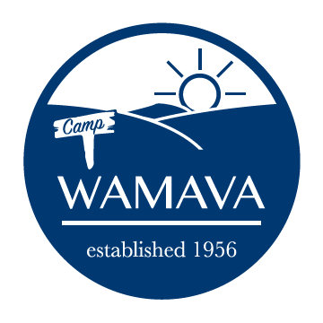
2023 Adult Volunteer Application

-Adult volunteers are needed each week as Kitchen Assistants, Bible Program Facilitators, and Nurses.
-All volunteers will be subject to a background check.
-All volunteers MUST attend one of our Zoom training sessions in order to be selected. We will schedule multiple Zoom sessions in early Spring.

Contact Information
Name:
Email:
Phone:
Church Congregation:
Desired Position: | (_) Kitchen Assistant (_) Bible Program (_) Camp Nurse
Number of people staying with you:

Week of Availability to Volunteer

If more than one week available, rank by preference (1 = highest)
Week 1 (Jun 18 – Jun 24); Grades 3,4,5,6 | (_)
Week 2 (Jun 25 – Jul 1); Grades 3,4,5,6 | (_)
Week 3 (Jul 2 – Jul 8); Grades 5,6,7 | (_)
Week 4 (Jul 9 – Jul 15); Grades 7,8,9 | ( )
Week 5 (Jul 16 – Jul 22); Grades 8,9,10 | ( )
Week 6 (Jul 23 – Jul 29); Grades 11,12, 2023 HS Grads | ( )

Special Requests

Please email completed application as a PDF or Word attachment to: director@wamava.com

